**Project and Developer Details**

**Project Name: LockedMe.com**

**Project Version 2.0**

**Project Details:**

It is file management system, which creates a root directory by creating a bin folder in the file application. It gives user the capability to list files/folder present in this root directory as well as add and remove files from this root directory. It also gives the user a capability to search all the files with a particular name in the directory.

**Developer Details:**

**Developer Name: Aakash Patel**

**Developer Simplilearn Userid: Aksh.2102**

**Sprint Details for the project**

**No. of Sprints Planned:** 2

**Sprint 1 Details:**

In the first sprint a basic structure to the application was developed, with the simple capability of listing the files present in the root directory.

The application has a three tier structure. The presentation layer, the business validation layer and the data access layer.

1. The presentation layer is the console, and the void main of the application corresponds to the presentation layer. It is responsible for taking the inputs from the user as well as showing the outcome/output to the user. Thus it is the layer which communicates with the user.
2. The Business Validation layer is responsible for validating the input from the user.
3. The data access layer process this user input and performs the operation as per the user input.

This basic structure was created using various classes and interfaces. Also the logic to list the files present in the root directory was developed.

**Sprint 2 Details:**

The above application was enhanced to incorporate additional features like addition/ removal/ search of a file.

This included creating a submenu. And adding the above options. New methods had to be created for this purpose.

**Application Logic/algorithm/flowchart**

The Application has a main menu, and a submenu. The main menu gives you an option to list all the files in the directory, navigate to the sub-menu and exit the application.

The sub-menu gives you an option to add a file, delete a file, search files from a directory.

Classes & Interface used to build the application:

|  |  |  |  |
| --- | --- | --- | --- |
| Sr. No. | Name | Class/interface | Remarks |
| 1 | LockedmeDAO | Interface | Data access object interface for the application |
| 2. | LockedmeDAOImpl | Class | Class that implements the LockedmeDAO interface. This has the core logic of the program |
| 3 | LockedmeBO | Interface | Business Object interface for the application |
| 4 | LockedmeBOImpl | Class | Class that implements the LockedmeBO interface. This has the logic for business validation layer. |
| 5 | FileObj | Class | Use to create the basic file objects and store data corresponding to a file. It is the model class of the application |
| 6 | BusinessException | Class | It inherits the class Exception. This class is used to implement exception handling in the application |
| 7 | Main | Class | It is the presentation layer of the application it has the Void Main function. |

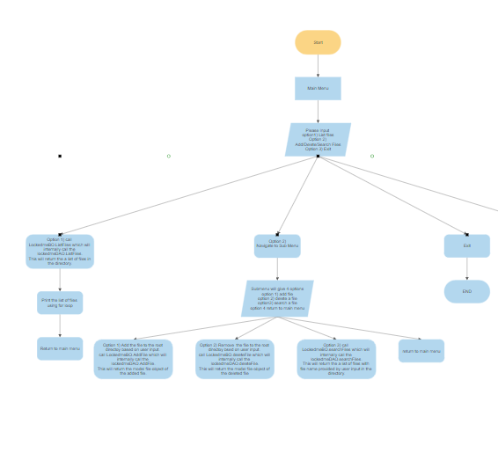

**Core concepts used in the project**

Java concepts implemented in this application:

1. Classes
2. Interface
3. Inheritance
4. Constructors
5. LinkedList
6. Constructors
7. Comparable Interface
8. Data Encapsulation (using private along with setters and getters)
9. Exception Handling
10. File class
11. For, While, Switch Case, If-Else ladder, and other logic related functions.

**Links to the GitHub repository to verify the project completion**

<https://github.com/aakashp2102/project_filemgmt>

**Conclusion**

There is a huge scope of improvement in the present project, one can easily add the functionality for navigating within folders, and adding, deleting files within a folder of the root directory. Also a functionality to write within the text files can be added. The USP of the project is that once fully developed it can act as a complete file management system and can be used by individuals to safe keep data in serialised form. That is an additional feature that needs to be implemented thereby one can keep his data in a secure format in the lockedme app.